Manual to add file in Google Drive
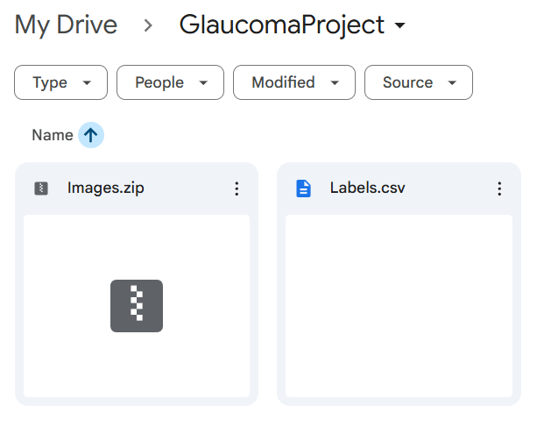
Put Images.zip and Labels.csv under GlaucomaProject in My Drive

